**Mercer County Clerk Presents Notary Education Class**

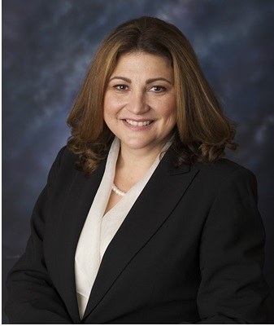

Wednesday, September 18th

10: 00 AM- 12:00 PM

***Mercer County Connection***

Hamilton Square Shopping Center, 957 Highway 33, Hamilton, NJ

*Mercer County Clerk, Paula Sollami Covello, invites you to come learn about being a New Jersey Notary Public. This seminar is for new and established notaries in New Jersey. Learn how to apply, to perform duties, and your legal responsibilities as a Notary Public.*

***Instructors: Maeve Cannon Esq., Ryan Kennedy Esq., Stevens and Lee Lawrenceville NJ and Mercer County Clerk Paula Sollami Covello***

_ _ _ _ _ _ _ _ _ _ _ _ _ _ _ _ _ _ _ _ _ _ _ _ _ _ _ _ _ _ _

For more information please call: (609) 989-6820

How can I register?

*There is a $15.00 registration fee for class materials and light refreshments. Please register by providing payment in the form of check or money order and provide the requested information below and Mail to: 209 South Broad Street Trenton NJ 08608, County Clerk’s Office, Attention*

*Selina Ortiz or Dena Sanna*



**Company Name­­­­­­­­­­­­­­­­­­­­­­­­­­­**______________________________________________­­­­­­­­_

**Attendee(s)**

**Name(s)­­­­­­­­­­­­­­­­­­­­­­­­**_____________________________________________________

**Telephone**­­­­­­­­­­­­­­­­­­­­­­­­­­­­­__________________________________ **Fax­­­­­­­­­­­­­­**__________________

**Email**­­­­­­­­­­­­­­­­_________________________________________________