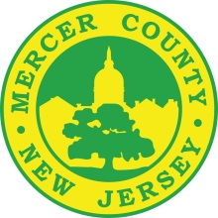

**Office of the Mercer County Clerk**

**For Immediate Release**

**Contact- 609-278-7161**

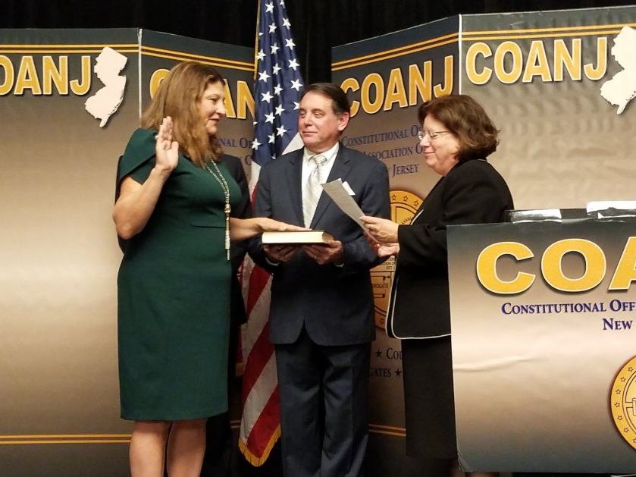**Sollami Covello Sworn in as New Vice President of COANJ**

Pictured: Mercer County Clerk Paula Sollami Covello is sworn in to be the new Vice President of COANJ. Her husband John and State Senator Linda Greenstein (D-Mercer, Middlesex) administer the oath.

Mercer County Clerk Paula Sollami Covello was recently sworn in to be the new Vice President of the Constitutional Officers Association of New Jersey. The swearing-in took place at their annual COANJ installment dinner at The Westin in Greater Princeton. She was elected to the position by her peers in the organization, based in all 21 counties of New Jersey.

Previously, Sollami Covello served as Secretary and Chief Clerk of COANJ, which is made up of County Clerks, Surrogates, and Registers of Deeds and Mortgages throughout the state. She also has served on various committees through the years.

“I’m so humbled to be entrusted to serve in a leadership role in an organization that does so much for New Jersey,” said the Mercer County Clerk. “Being the Vice President is an honor, and I will look forward to help shape the agenda for the future of the organization by working with the members of COANJ or the residents of our state.”

The Constitutional Officers Association of New Jersey was founded in 1920. Its primary goal, as stated on their website, is “To establish a cooperative effort among the Sheriffs, County Clerks, Surrogates and Registers of Deeds among the 21 counties of the State of New Jersey to improve services rendered to their respective constituencies.” In addition to several smaller meetings throughout the year, the constitutional officers hold an annual conference and installment dinner to educate members on emerging topics, swear in new officers, and discuss best practices to improve services throughout the members’ respective counties of New Jersey. County Clerks play a pivotal role in elections, land records management, legal documents, law enforcement, and many other governmental procedures in the state, while surrogates probate wills and estates and sheriffs are instrumental in protecting citizens and courts.