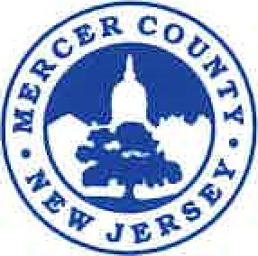

**MERCER COUNTYBOARD OF TAXATION**

**McDade Administration Building**

**640 South Broad Street P.O. Box 8068**

**Trenton, New Jersey 08650-0068**

**TINA M. ROONEY, CTA PHONE: (609) 989-6704**

**Tax Administrator FAX: (609) 396-4510**

**MERCER COUNTY BOARD OF TAXATION**

**MINUTES**

**June 14, 2022**

The meeting of the Mercer County Board of Taxation was called to order at 9:04 a.m. by Commissioner Richard Carabelli. In attendance were Commissioners Rose-Marie Bowen-Lewis, Fareeda Stokes, Frank Ragazzo (at 9:38 a.m.), Edward Hoffman, Tax Administrator Tina Rooney, Assistant Tax Administrator Erica Brandmaier.

After a statement that the provisions of the Open Public Meetings Act had been met, Commissioner Carabelli began with the approval of the equalization table.

Appeals for the following towns were heard:

East Windsor Township

Ewing Township

Hamilton Township

Hopewell Township

Robbinsville Township

West Windsor Township

Princeton

With no further business coming before the Board, the meeting was adjourned at 1:27 p.m.

Respectfully Submitted by,

Erica J. Brandmaier, CTA

Assistant Tax Administrator