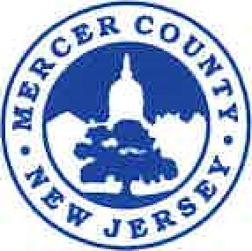

**MERCER COUNTYBOARD OF TAXATION**

**McDade Administration Building**

**640 South Broad Street P.O. Box 8068**

**Trenton, New Jersey 08650-0068**

**TINA M. ROONEY, CTA PHONE: (609) 989-6704**

**Tax Administrator FAX: (609) 396-4510**

**MERCER COUNTY BOARD OF TAXATION**

**MINUTES**

**February 13, 2023**

The meeting of the Mercer County Board of Taxation was called to order at 9:03 a.m. by President Richard Carabelli. In attendance were Commissioners Rose-Marie Bowen-Lewis, Fareeda Stokes, Tax Administrator Tina Rooney, Assistant Tax Administrator Erica Brandmaier. Absent were Commissioners Edward Hoffman and Frank Ragazzo

A statement was read that the provisions of the Open Public Meetings Act had been met.

President Carabelli stated that he would like the assessors to get together and come to a consensus in getting a letter together when sending out the administrative changes to property owners. He would like to have all of the assessors participate in this letter and when the draft is complete, have Administrator Rooney review for all of the assessors to use when sending out notifications.

Administration changes were approved for the following towns:

Hamilton Township

Hopewell Township

City of Trenton

Robbinsville Township

West Windsor Township

Princeton

The Ewing Township administrative changes were tabled with the exception of the pipeline until the Board has time to review them.

With no further business coming before the Board, the meeting was adjourned at 9:28 a.m.

Respectfully Submitted by,

Erica J. Brandmaier, CTA

Assistant Tax Administrator