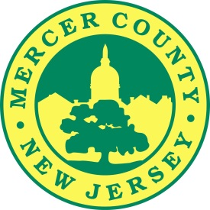

**\*2016-2017 Holiday Closures for the Mercer County Clerk\***

**The Mercer County Clerk’s Office will have special hours during the holidays!**

**The regular Wednesday evening hours in Trenton will NOT be held on the following date:**

* **Wednesday, November 23rd (the evening before Thanksgiving). We will CLOSE at 4 PM.**

**\*Please note that our County Connection office in Hamilton Township will be OPEN on the Saturday following Thanksgiving, November 26th, from 10AM to 2PM.**

**CLOSURES- Both the main Trenton office and County Connection are CLOSED on these dates.**

**Thanksgiving Holiday**

* **Thursday, November 24, 2016**
* **Friday, November 25, 2016**

**Christmas Holiday**

* **Saturday, December 24, 2016**
* **Monday, December 26, 2016**

**New Year’s Holiday**

* **Saturday, December 31, 2016**
* **Monday, January 2, 2017**

**Thank you and Happy Holidays!**

*Paula Sollami Covello, Esq*.