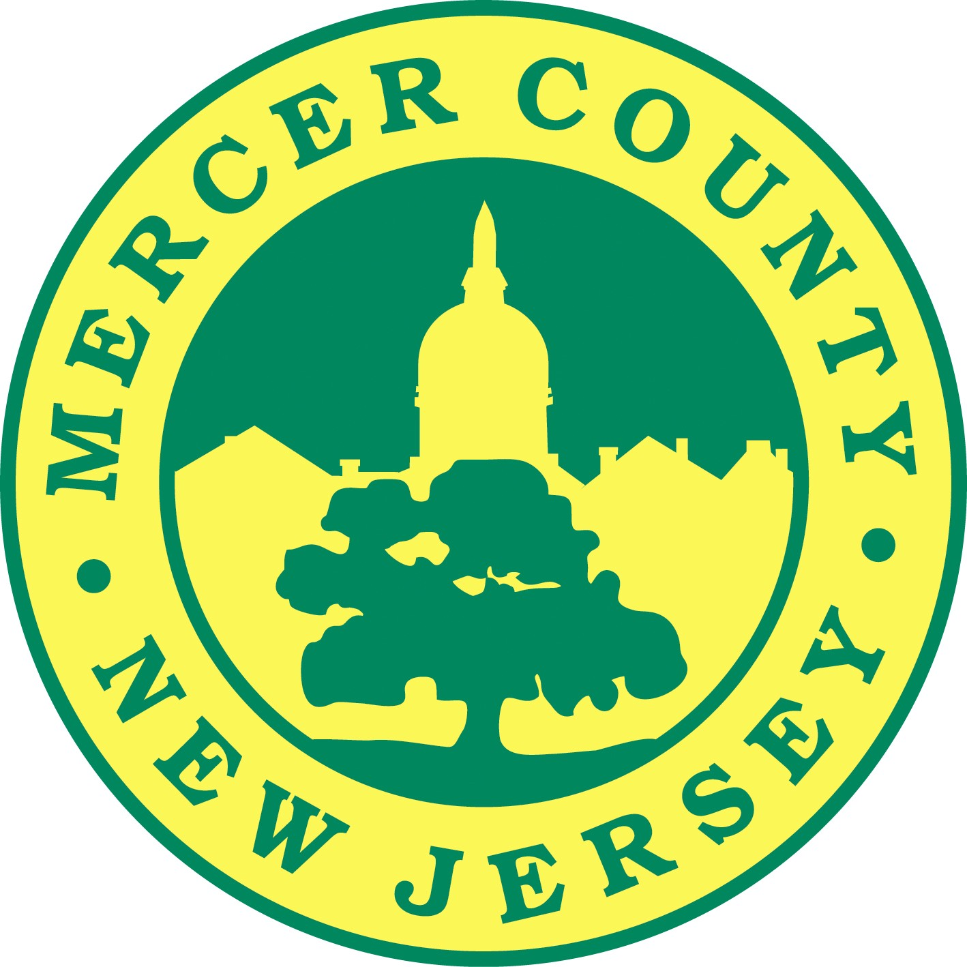

Contact Information:
Paula Sollami Covello
Mercer County Clerk 609-989-6820
www.mercercounty.org/CountyClerk
Twitter @MercerClerk

FOR IMMEDIATE RELEASE

MERCER COUNTY CLERK ANNOUNCES N.J. NOTARY OATH NIGHTS FOR 2018

Mercer County Clerk Paula Sollami Covello will hold special N.J. Notary Oath Nights at the Mercer County Connection on the first Thursday of every month throughout 2018. County residents who have received their initial notary public commission, or renewal, from the Department of Treasury office must be properly sworn in by the County Clerk’s Office in order to officially become a notary public.

“Becoming a public notary is a way to diversify a small business, create additional sources of income, and to provide extra services for an already established business or firm,” notes Sollami-Covello, “Many individuals, such as lawyers and realtors, find providing these additional services to be extremely beneficial.”

The NJ Notary Oath Nights for 2018:

- Thursday- January 4, 2018
- Thursday- February 1, 2018
- Thursday- March 1, 2018
- Thursday- April 5, 2018
- Thursday- May 3, 2018
- Thursday- June 7, 2018
- Thursday- July 5, 2018
- Thursday- August 2, 2018
- Thursday- September 6, 2018
- Thursday- October 4, 2018
- Thursday- November 1, 2018
- Thursday- December 6, 2018

The county fee is $15 and payment can be made via check, money order, or credit card. The Mercer County Connection is located in the Hamilton Square Shopping Center at 957 Route 33 and Paxson Avenue in Hamilton.

For those who will be unable to participate in Notary Public Night, the Mercer County Clerk’s office swears in notary commissions on a regular basis, Monday through Friday 8:30 am to 4:00 pm and Wednesdays until 6:45 pm at the County Clerk’s Office, 240 West State Street in Trenton. For further information and to download an official Notary Public application, go to www.mercercounty.org/CountyClerk and click “Office Services” and then “Notary Public”.

**Please note: Our office location will change in Fall 2018 to the Courthouse Annex at
209 S Broad St, Trenton**

###

